Mini project

Source code:

#include <stdio.h>

#include <conio.h>

void show();

void sum();

void sub();

void avg();

void fac();

void sub();

void prime();

void leap();

void multi();

void divs();

int main()

{

int n;

printf("Welcome to c program to solve basic life problem related to maths(like add,sub,leap year etc.\n");

show();

printf("\nPlease Select the problem number you want to solve\n");

scanf("%d",&n);

if(n==1){

sum();

}

else if(n==2)

{

sub();

}

else if(n==3){

avg();

}

else if(n==4){

fac();

}

else if(n==5){

prime();

}

else if(n==6){

leap();

}

else if(n==7){

multi();

}

else if(n==8){

divs();

}

else{

printf("Invalid number/NUMBER not founded");

}

return 0;

}

void show()

{

printf("1.summation\n");

printf("2.substraction\n");

printf("3.Average\n");

printf("4.factorial\n");

printf("5.Prime number check\n");

printf("6.Leap year check\n");

printf("7.multiply\n");

printf("8.division\n");

}

void sum()

{

int i, n, num, sum=0;

printf("Enter how many numbers to add: ");

scanf("%d", &n);

printf("Enter %d numbers: ", n);

for(i=0; i<n; i++)

{

scanf("%d", &num);

sum = sum+num;

}

printf("\nSum of all %d numbers = %d", n, sum);

}

void sub()

{

int x,y,z;

printf("Enter the two values to substract:\n");

scanf("%d\n%d",&x,&y);

z=x-y;

printf("%d",z);

}

void avg( )

{

int n, count = 1;

float x, average, sum = 0;

printf("Enter the value of n?\n");

scanf ("%d",&n);

while (count <= n)

{

printf ("Enter the %d number?\n",count);

scanf("%f", &x);

sum += x;

++count;

}

average = sum/n;

printf("\nThe Average is %f\n", average);

}

void fac()

{

int i,fact=1,number;

printf("Enter a number: ");

scanf("%d",&number);

for(i=1;i<=number;i++){

fact=fact\*i;

}

printf("Factorial of %d is: %d",number,fact);

}

void prime()

{

int n,i,m=0,flag=0;

printf("Enter the number to check prime:");

scanf("%d",&n);

m=n/2;

for(i=2;i<=m;i++)

{

if(n%i==0)

{

printf("Number is not prime");

flag=1;

break;

}

}

if(flag==0)

printf("Number is prime");

}

void leap() {

int year;

printf("Enter a year: ");

scanf("%d", &year);

if (year % 400 == 0) {

printf("%d is a leap year.", year);

}

else if (year % 100 == 0) {

printf("%d is not a leap year.", year);

}

else if (year % 4 == 0) {

printf("%d is a leap year.", year);

}

else {

printf("%d is not a leap year.", year);

}

}

void multi()

{

int i, n, num, mul=1;

printf("Enter how many numbers to multiply: ");

scanf("%d", &n);

printf("Enter %d numbers: ", n);

for(i=0; i<n; i++)

{

scanf("%d", &num);

mul = mul\*num;

}

printf("\nmultiply of all %d numbers = %d", n, mul);

}

void divs()

{

float a, b;

printf("Enter value for a and b, for division (a/b)\n");

scanf("%f\n%f", &a, &b);

if( b != 0 )

printf("Division of %f and %f is %f\n", a, b, a/b);

if( b == 0 )

printf("You can't divide a number by 0\n");

}

Output: 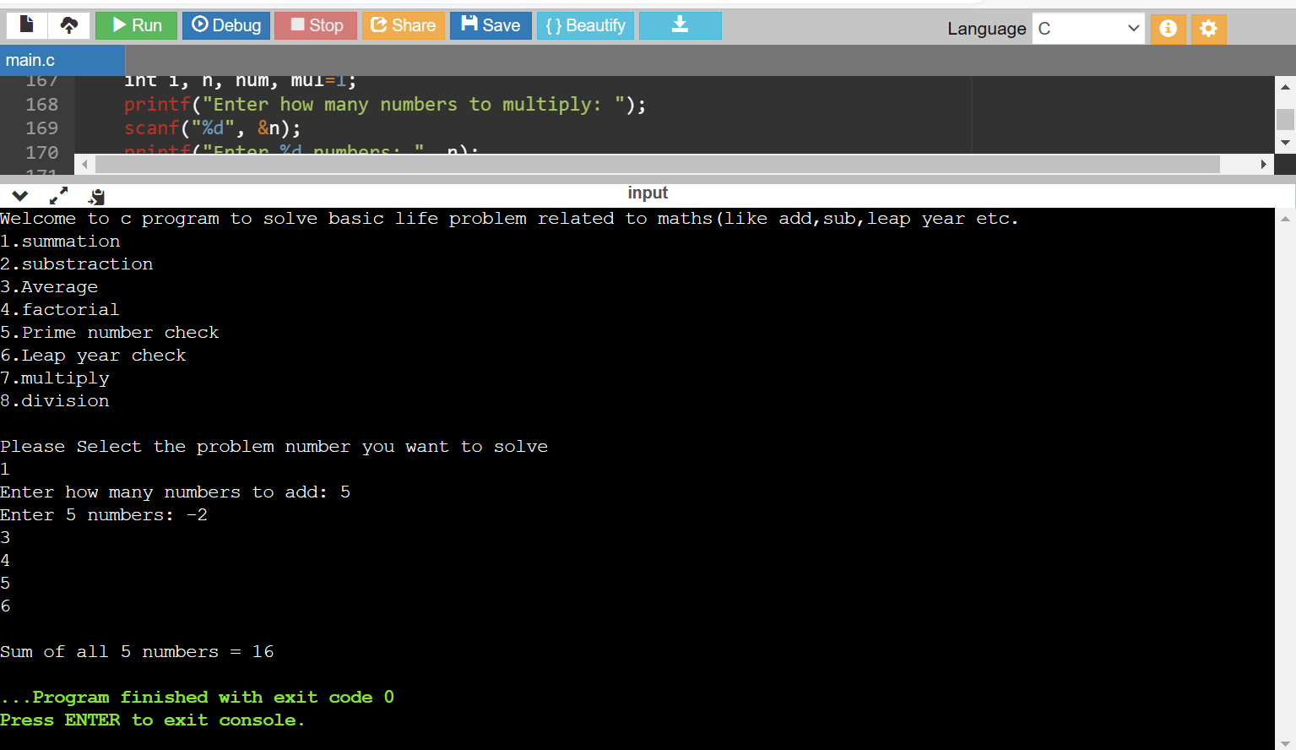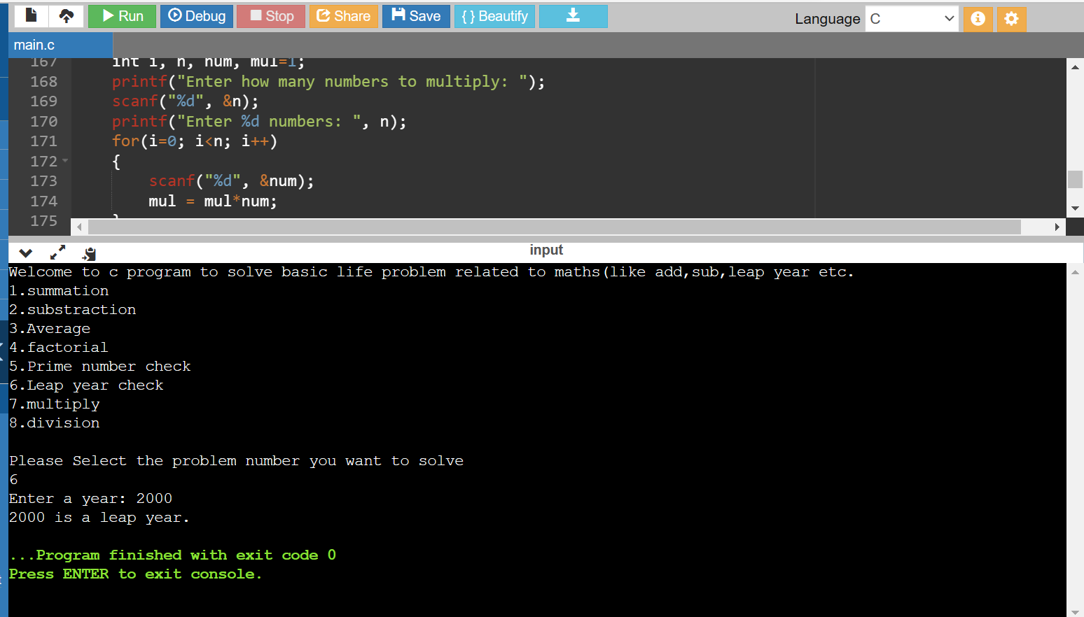

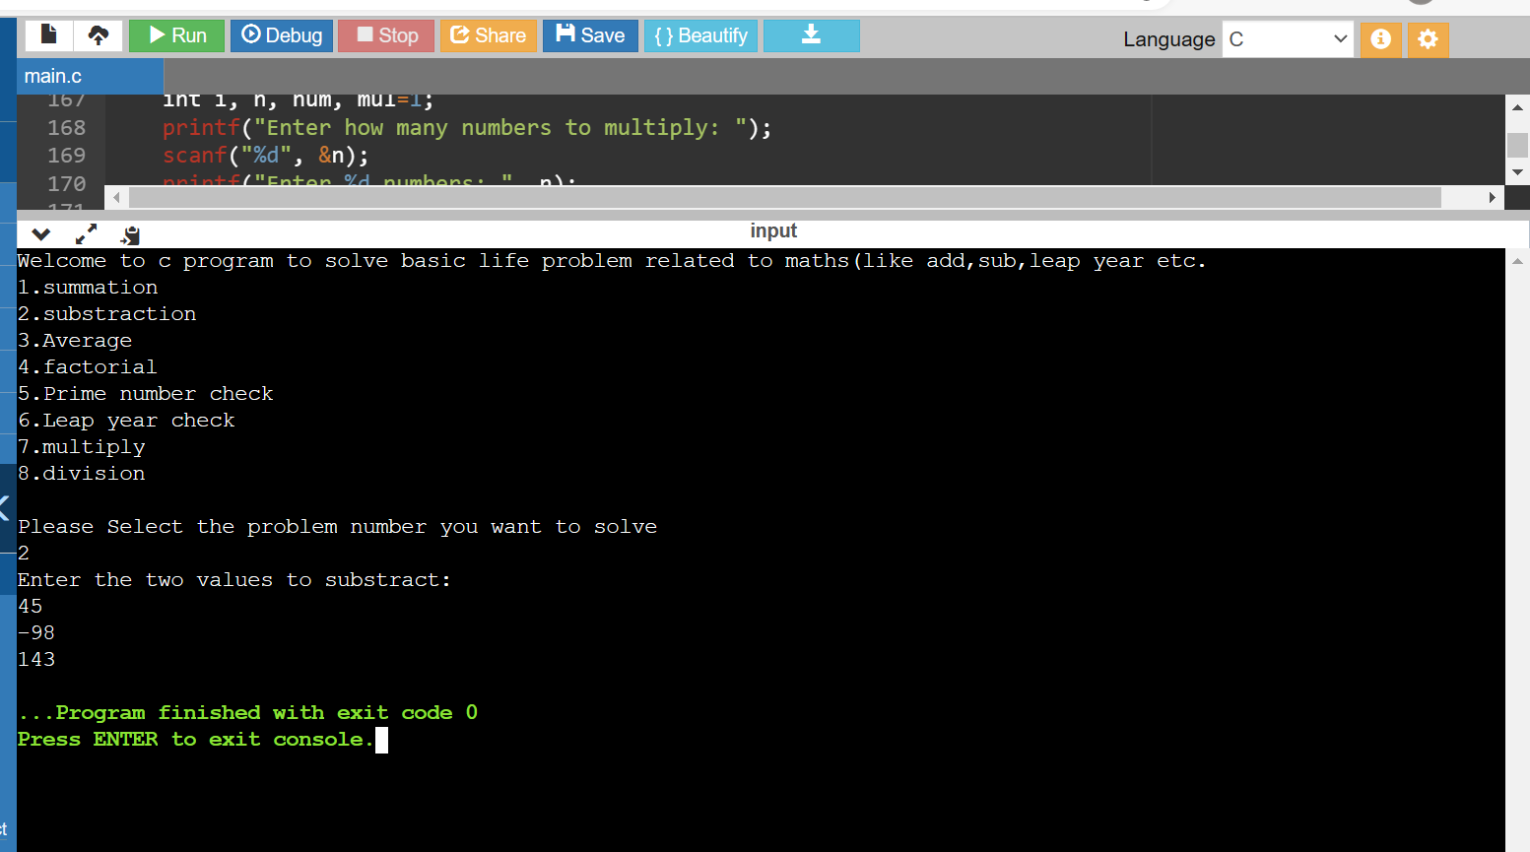

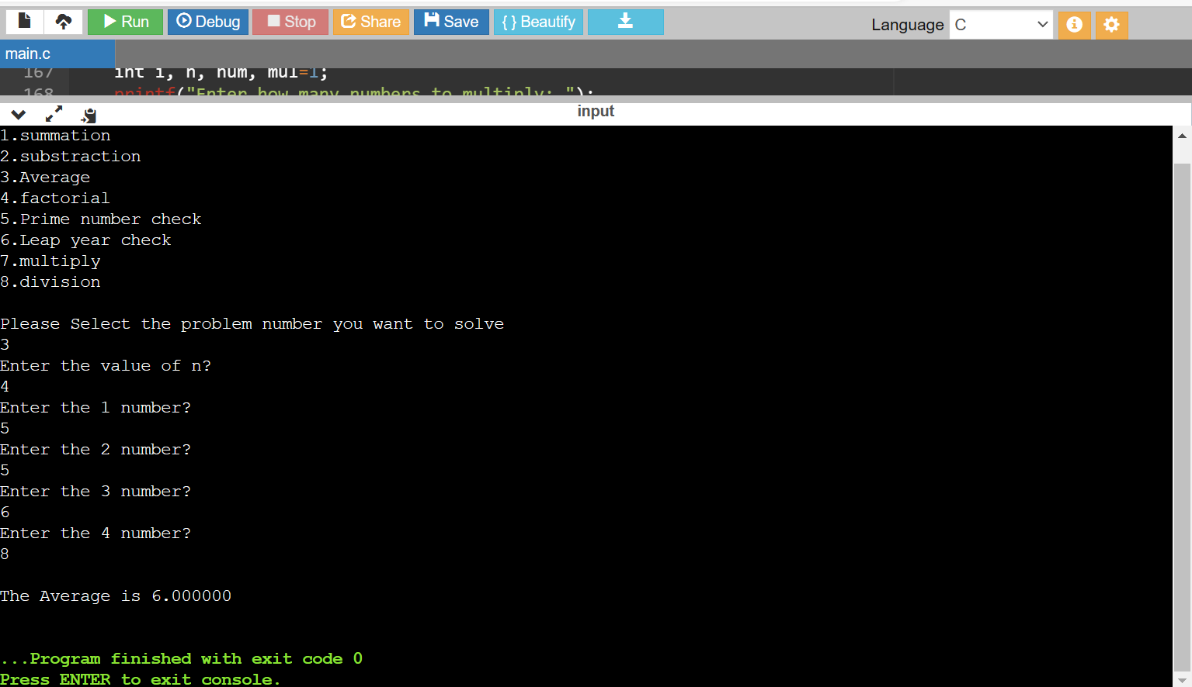

Profiling: 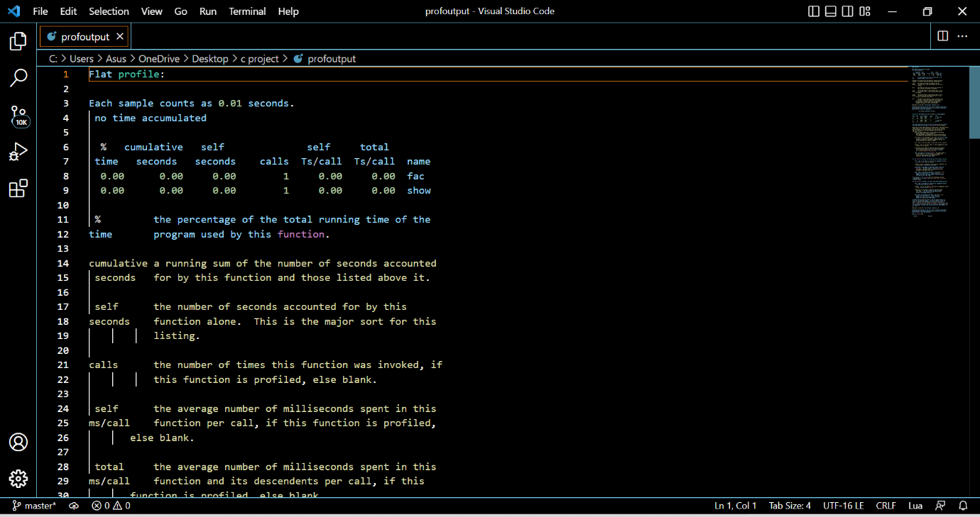



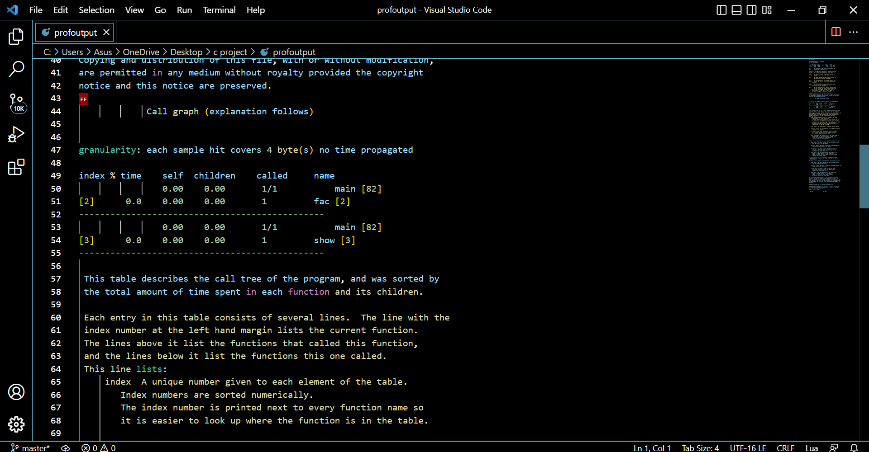

Debbuging: 